**1.Prime Number: Anonymous Function**

var numArray = [2, 3, 4, 5, 6, 7, 8, 9, 10]

var numArray = numArray.filter(function (number) {

for (var i = 2; i <= Math.sqrt(number); i++) {

if (number % i === 0) return false;

}

return true;

});

console.log(numArray);

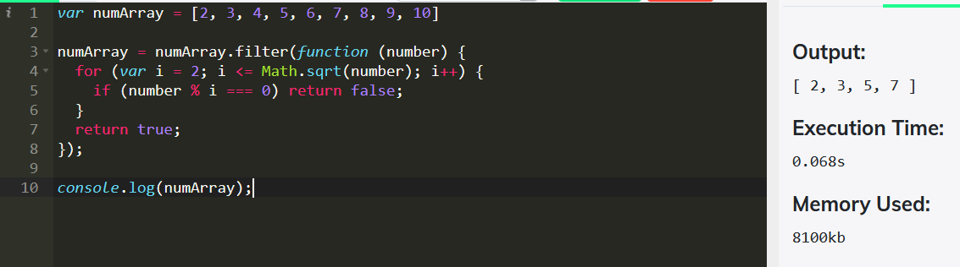

**Arrow Function:**

let isprime = (num) => {

if(num<2){

return false; // if number is 0 or 1 it returns false

}

for(i=2;i<num; i++){

if(num%i===0){

return false;

}

}

return true;

}

console.log(isprime(8));

console.log(isprime(7));

console.log(isprime(5));

console.log(isprime(4));

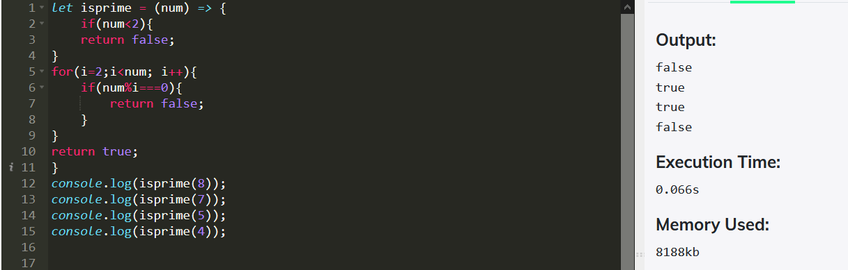

**2.Odd Number : Anonymous Function**

var numarr=[21,22,23,24,25];

var oddnumber = numarr.filter(function(element){

return element%2!==0;

});

console.log(oddnumber)

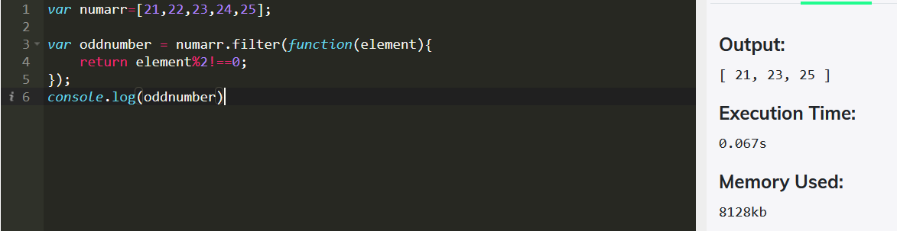

**Arrow Function :**

var numbers=[21,22,23,24,25];

var OddNumbers = numbers.filter(number => number % 2);

console.log(OddNumbers);

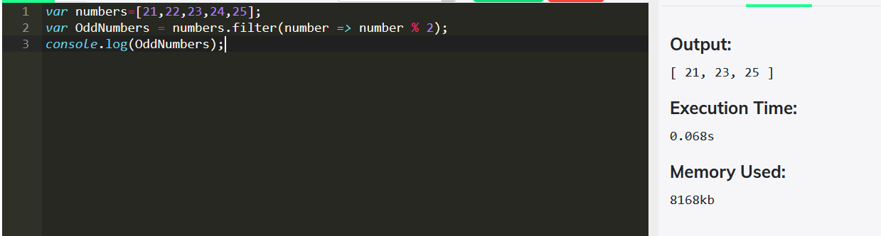

**3. Add Number : Arrow Function**

var sum = (a,b,c) => a+b+c;

var result = sum(100,90,10);

console.log(result);

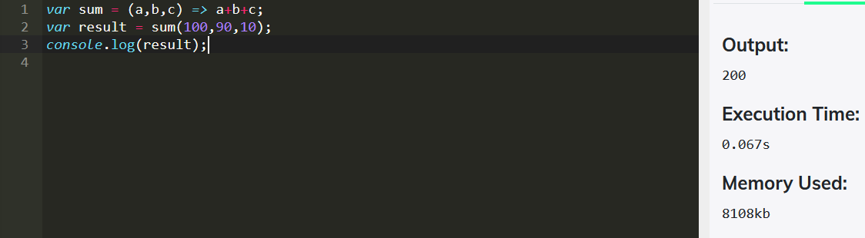

**Anonymous Function :**

var sum=[10,20,30]

var result=sum.reduce(function(element,index){

return result+index;

}, 0 );

console.log(result)

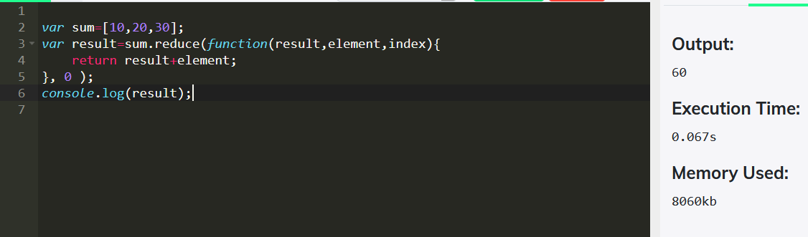

**4.Palindrome or not : Arrow function**

var word =(str) => {

console.log(str.split('').reverse().join(''));

return str === str.split('').reverse().join('');

}

console.log(word('racecar'))

console.log(word('madam'))

console.log(word('Saran'))

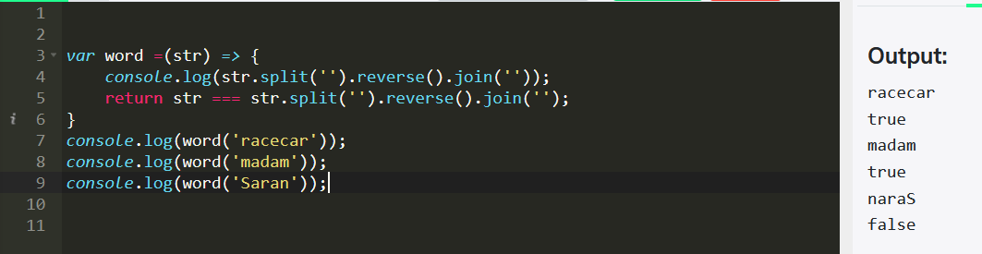

**Anonymous Function:**

var items = ['mum', 'dad', 'brother'];

var result = items.map(function(item) {

return item.split('').reverse().join('') === item; //reverse the element in the array and join the aaray

});

console.log(result)

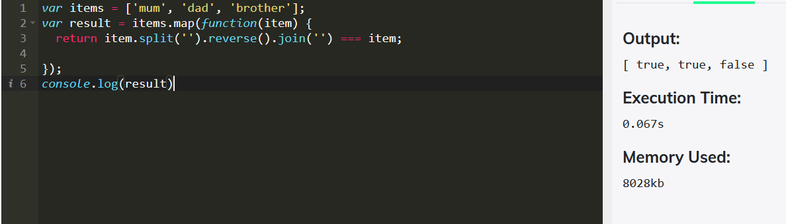

**5**.**Capitalize the First word: Arrow function**

var animals =['elephant','lion','tiger','hyena','fox'];

var modifiedanimals = animals.map (item =>item[0].toUpperCase() + item.slice(1));

console.log(modifiedanimals);

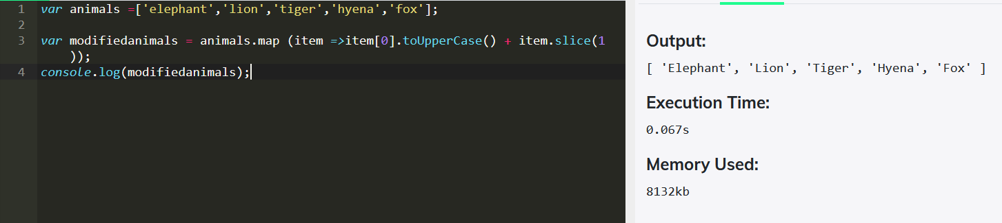

**Anonymous Function**

var days = ['sunday', 'monday', 'tuesday', 'wednesday', 'thursday', 'friday', 'saturday'];

var newDays = days.map(function(day){

var a =(day.charAt(0).toUpperCase() + day.slice(1).toLowerCase()); //remove charat(0) and slice (1)

return a;

})

console.log(newDays)

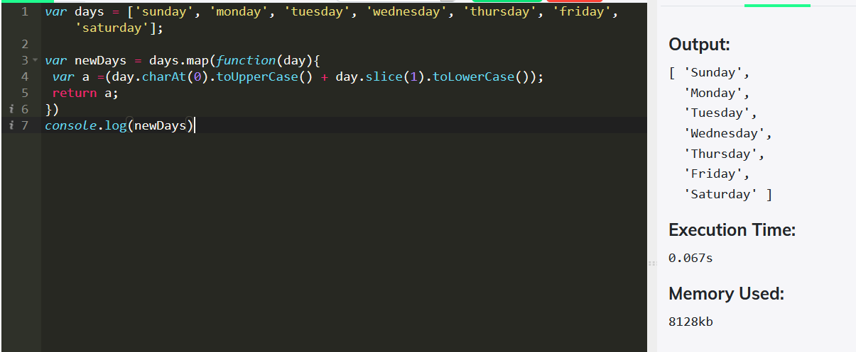

**6. Removing Duplicates Elements from the Array:**

var cities = ["Delhi","Mumbai","Chennai","Hyderabad","Mumbai","Chennai","Delhi","Bangalore"]

var newcities = cities.filter(function(element,index){

return cities.indexOf(element)===index;

});

console.log( newcities)

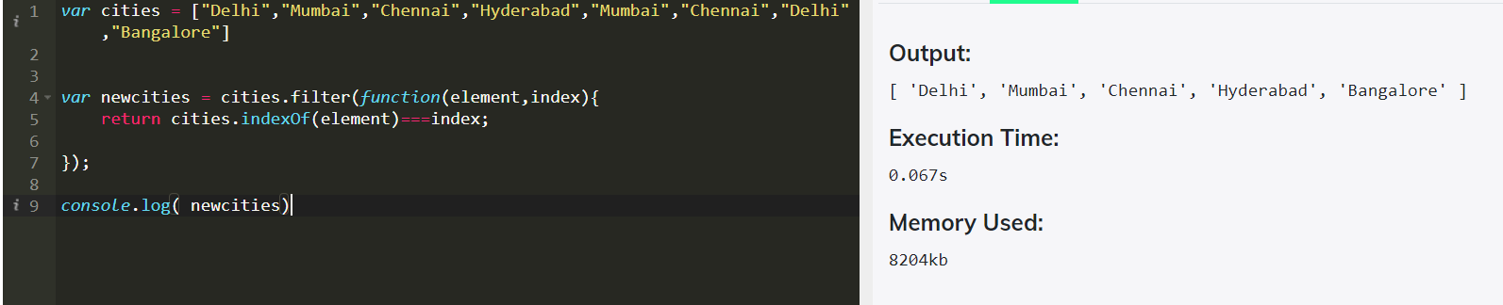

var Dishes = ["Pizza","Burger","Briyani","Friedchicken","Briyani","Pulao","Burger"]

var AvailableDishes = Dishes.filter((element,index)=>{

return Dishes.indexOf(element)===index;

});

console.log(AvailableDishes)

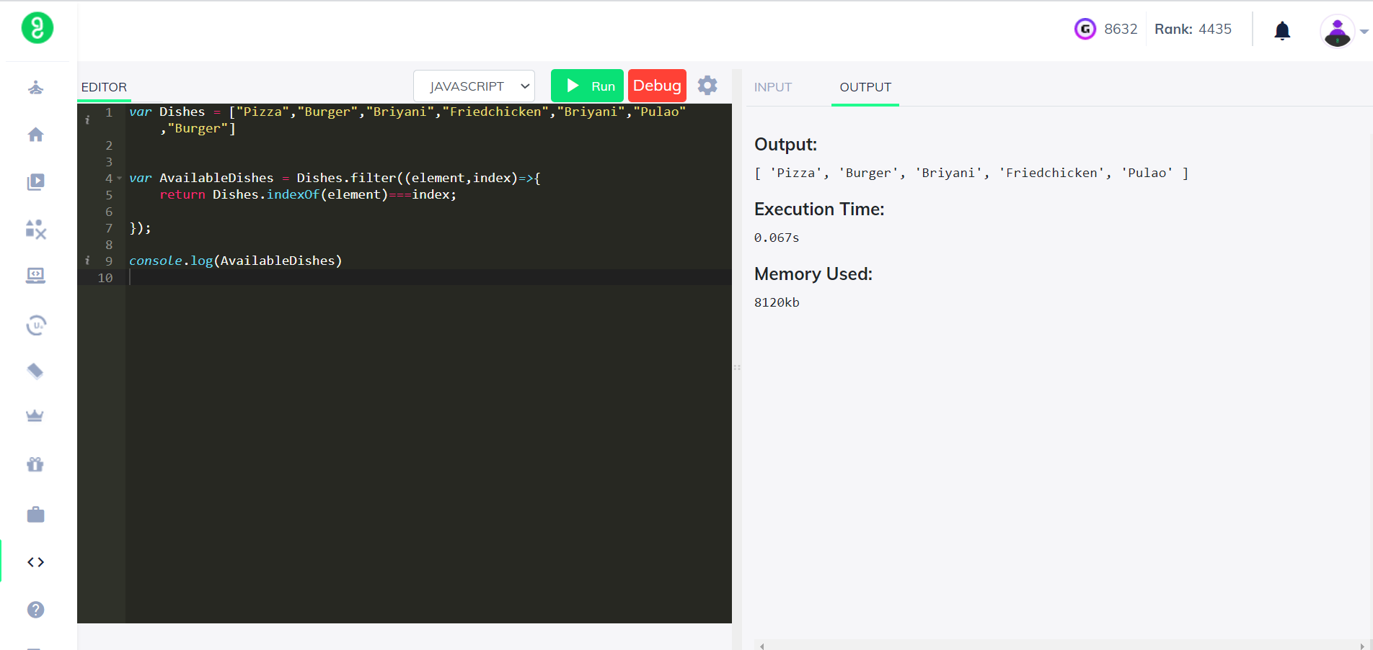

**7.Find the Median of the Array: (Arrow Function)**

var a=[1,3,5,7,9,11];

var b=[2,4,6,8,10,12];

var concat=[...a,...b];

var sort=concat.sort(function(a, b) {

return a - b;

});

console.log(sort)

var value = Math.floor(concat.length/2) //Math.floor =6

var result= concat =>{

if(concat.length%2===0)

{

return concat[value - 1] + concat[value]; // =>7+6 => 13

}

else{

return concat[value]

}

}

console.log(result(concat)/2)

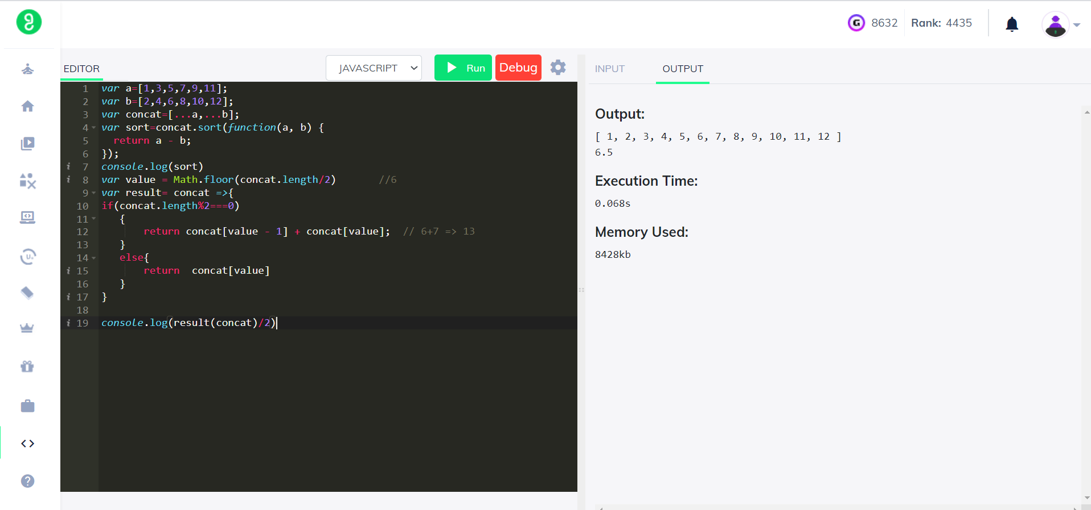

**8. Rotating Array by K times: Arrow Function**

var numbers= [1,2,3,4,5,6,7];

var k=4; // number of rotation

var rotate = (nums, k) => {

for (let i = 0; i < k; i++) {

nums.unshift(nums.pop()); //unshift add 2 number, pop removes last element in array and it pops.

}

return nums;

}

console.log(rotate(numbers,k));

